

SSRS Reports in MAP

#### Document History

|  |  |  |  |  |  |
| --- | --- | --- | --- | --- | --- |
| Date | Version | Revision Details | Author | Reviewed By | Approved By |
| 14 Sep 2015 | 1.0 | SSRS Reports in MAP | Ajith PA | Mahesh KM |  |
|  |  |  |  |  |  |

#### Table of Contents

|  |  |  |
| --- | --- | --- |
| Sl No | Section | Page No |
| 1 | Introduction | 4 |
| 2 | Map Global Reports | 4 |
| 3 | Map Agency Report | 7 |
| 4 | Map End User Report | 11 |
|  |  |  |

## INTRODUCTION

Report management system is used to manage SSRS and AD-HOC reports in map. SSRS Component in MAP have 3 main modules.

* MAP Global Reports
* MAP Agency Reports
* MAP End User Reports

**MAP Global Reports**:

This component can be accessible only for MAP Portal Admins. This is the report configuration component where reports are mapped to each agencies. Portal admin can assign reports to different agencies. Global report details are saving in Irriscentral database.

Configuration -> Profile data -> Master data -> MAP Agency Reports section of portal admin section.

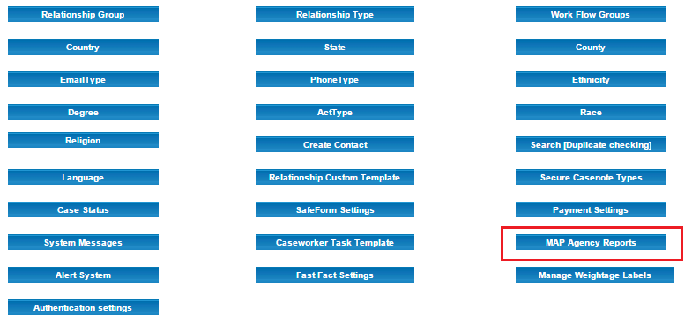

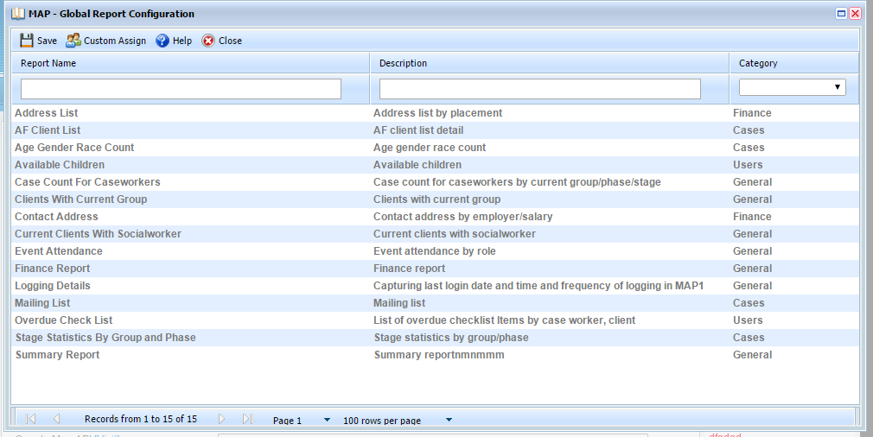

Tables**:**

RptCategory: It is used to store different report categories. CategoryId is the primary key in this table which is negative.

|  |  |  |  |
| --- | --- | --- | --- |
| **rptCategory** | | |  |
| **Column_name** | **Type** | **Length** |  |
| CategoryID | int | 4 | |  | | --- | |  | | |  | |
| Description | varchar | 30 |
| DeletedYN | bit | 1 |
| CreatedBY | int | 4 |
| CreatedDate | datetime | 8 |
| LastModifiedBy | int | 4 |
| LastModifiedDate | datetime | 8 |

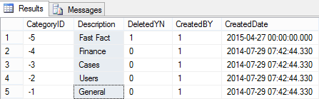

RptReportMaster: It is used to store report details like Reportname, ReportPath, and DisplayName CategoryId etc. ReportId (Negative) is the primary key in this table.

|  |  |  |  |
| --- | --- | --- | --- |
| **rptReportMaster** | | |  |
| **Column_name** | **Type** | **Length** |  |
| ReportID | int | 4 | |  | | --- | |  | | |
| ReportName | varchar | 50 |
| DisplayText | varchar | 50 |
| Description | varchar | 500 |
| ReportPath | varchar | 1000 |
| CategoryID | int | 4 |
| DeletedYN | bit | 1 |
| CreatedBY | int | 4 |
| CreatedDate | datetime | 8 |
| LastModifiedBy | int | 4 |
| LastModifiedDate | datetime | 8 |

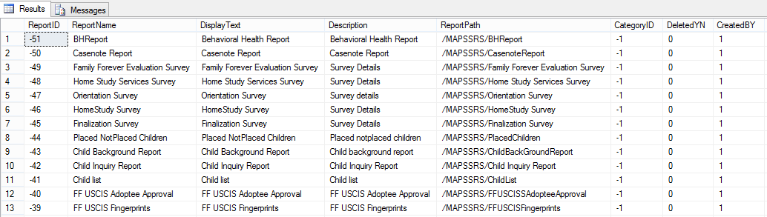

RptAgencyAssignment: This table is used to store reports which is assigned to agencies.

|  |  |  |  |
| --- | --- | --- | --- |
| **rptAgencyAssignment** | | |  |
| **Column_name** | **Type** | **Length** |  |
| AssignmentId | int | 4 | |  | | --- | |  | | |
| ReportID | int | 4 |
| AgencyID | int | 4 |
| CategoryID | int | 4 |
| DeletedYN | bit | 1 |
| CreatedBY | int | 4 |
| CreatedDate | datetime | 8 |
| LastModifiedBy | int | 4 |
| LastModifiedDate | datetime | 8 |

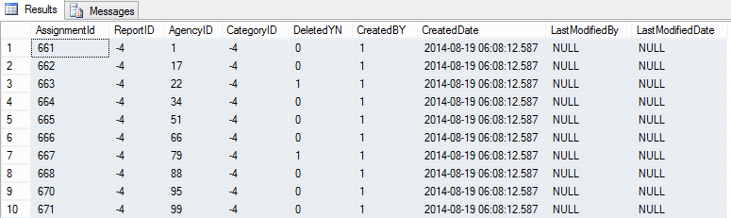

**MAP Agency Reports**:

This component is accessible for MAP Portal Admins as well as MAP Agency Admins. Here agency can assign reports and filters to individual users or groups.

Configuration -> Profile data -> Master data -> MAP Agency Reports section.

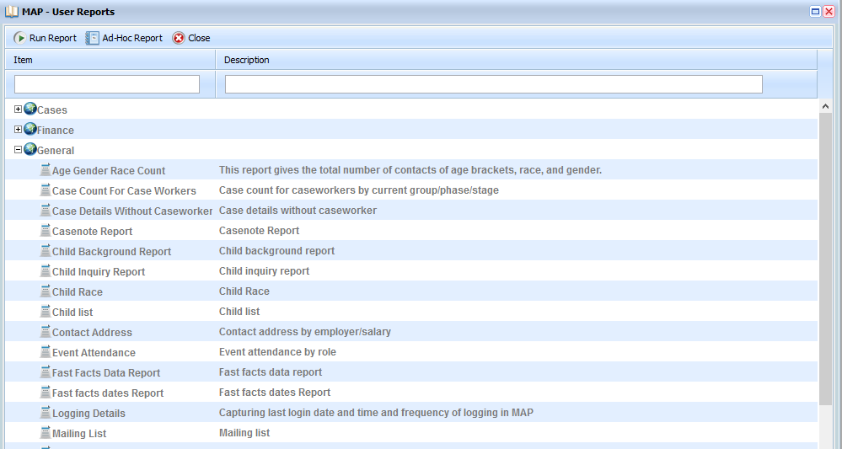

Tables:

**RptCategory**: Save different categories in agency level. Here we can save two types of report categories. One is categories created by portal admin and the other is created by agency. Negative category id represents those categories are created by Portal admin. Positive categories represents those categories are created by Agency itself.

|  |  |  |  |
| --- | --- | --- | --- |
| **rptCategory** | | |  |
| **Column_name** | **Type** | **Length** |  |
| CategoryID | int | 4 | |  | | --- | |  | | |
| Description | varchar | 30 |
| DeletedYN | bit | 1 |
| CreatedBY | int | 4 |
| CreatedDate | datetime | 8 |
| LastModifiedBy | int | 4 |
| LastModifiedDate | datetime | 8 |

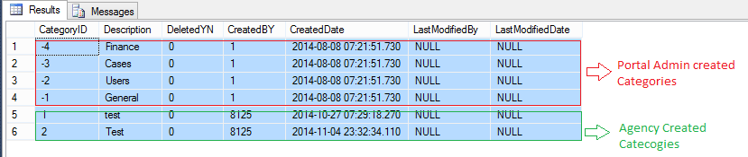

RptReports: This table is used to save report details in agency level. Here category id =0 means those are standalone reports which have no categories.

|  |  |  |  |
| --- | --- | --- | --- |
| **rptReports** | | |  |
| **Column_name** | **Type** | **Length** |  |
| ID | int | 4 | |  | | --- | |  | | |
| ReportID | int | 4 |
| ReportName | varchar | 50 |
| DisplayText | varchar | 50 |
| Description | varchar | 500 |
| CategoryID | int | 4 |
| ReportPath | varchar | 1000 |
| DeletedYN | bit | 1 |
| CreatedBY | int | 4 |
| CreatedDate | datetime | 8 |
| LastModifiedBy | int | 4 |
| LastModifiedDate | datetime | 8 |
| ReportType | int | 4 |

~~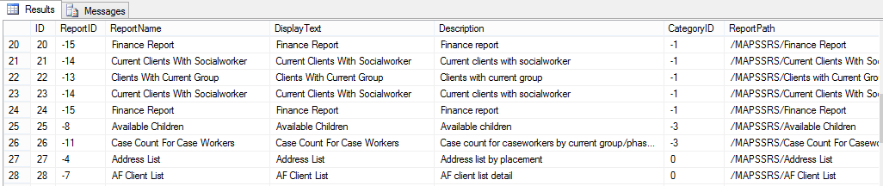~~

Filter Assignment: Agency admin can assign filters to individual reports.

SELECT a report ->click Report Filter->Click Filters to be assigned

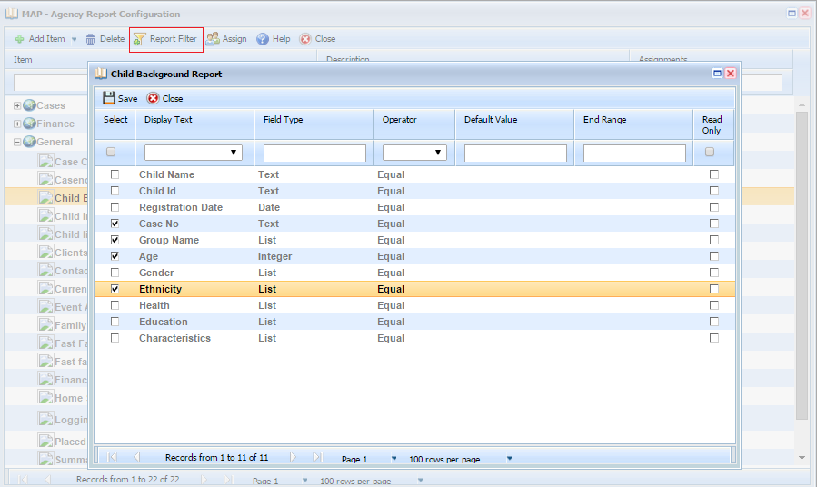

RptFilters: This table is used to store filters for all reports. Here Report id is foreign key which is referenced from rptreports table. Field type column represents the filter type like Dropdown, Date, and Email etc.

|  |  |  |
| --- | --- | --- |
| **Field** | **Id** | |
| String | 1 | |
| SSN | 2 | |
| Phone | 3 | |
| Date | 4 | |
| Integer | 5 | |
| Email | 6 | |
| Price | 7 | |
| Dropdown | 8 | |
| RptFilters | | | | |  |
|  | | | | |  |
| **Column_name** | | **Type** | | **Length** |  |
| FilterID | | int | | 4 | |  | | --- | |  | | |
| ReportID | | int | | 4 |
| FieldName | | varchar | | 300 |
| DisplayText | | varchar | | -1 |
| FieldType | | int | | 4 |
| DefaultValue | | varchar | | 100 |
| EndRange | | varchar | | 100 |
| sequence | | int | | 4 |
| LookUpId | | int | | 4 |

Here LookUpId column represents the id from the lkplookupTable. Which is used to fill the drop down.

|  |  |  |  |
| --- | --- | --- | --- |
| **lkplookupTable** | | |  |
| **Column_name** | **Type** | **Length** |  |
| Id | int | 4 | |  | | --- | |  | | |
| LkpName | varchar | 250 |
| DisplayField | varchar | 250 |
| ValueField | varchar | 250 |
| Query | varchar | -1 |
| Parameter | varchar | 250 |

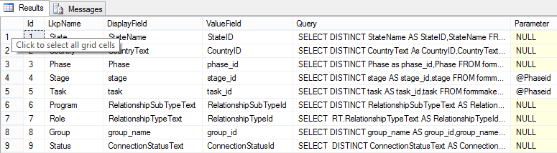

**User/Group Assignment:**

Agency admin can assign report to individual/ group of users in the agency.

Select a report ->click Assign -> Click users/ Groups to be assigned.

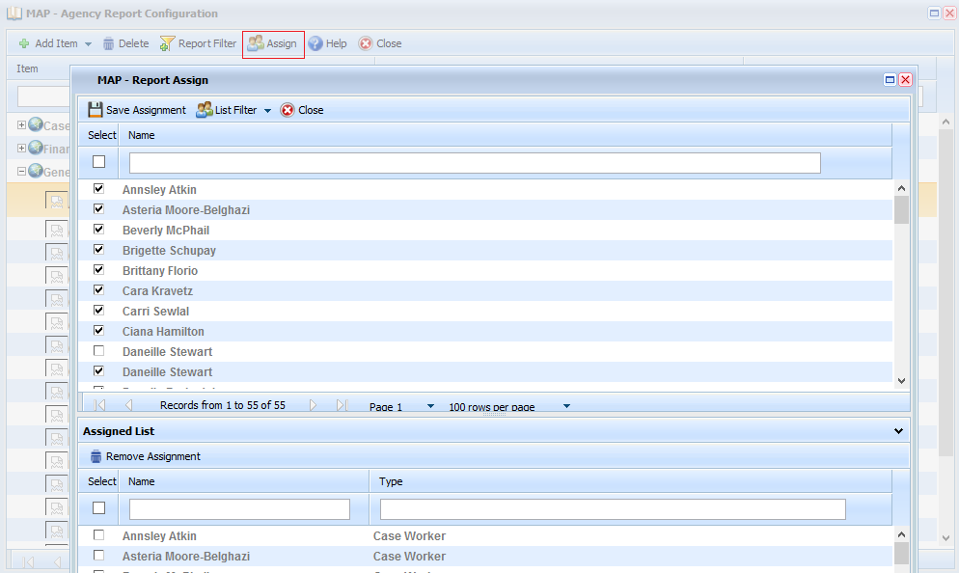

**MAP End-user Reports**:

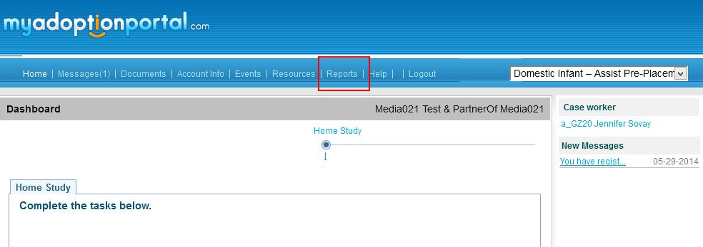

This component is for MAP end users. This will be available on end user login. This component generate reports for the end user. The component has a toolbar and a treegrid which lists all the reports filtered by category. Selecting a report from the grid and clicking ‘Run’ button will open a new window which lists all the filters for that report. From that window the user can select conditions for generating the reports and Execute and generates report.

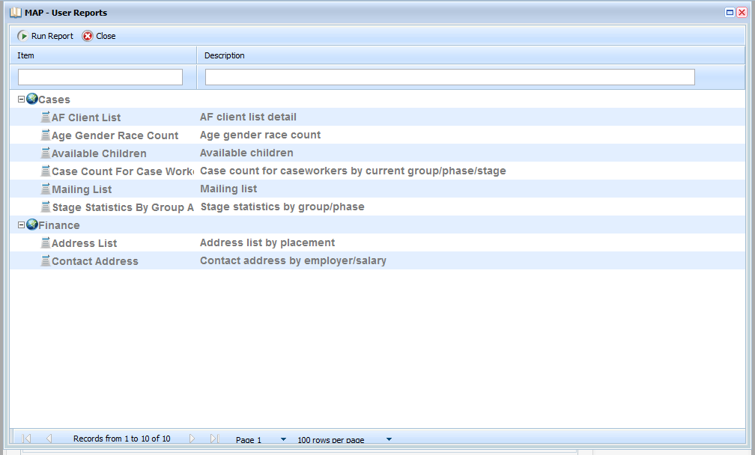

Run Report:

Will open a new window which lists all the filters assigned for this component. From here the user can select conditions for the filter and execute the report. Executing the report and generates report in selected format.

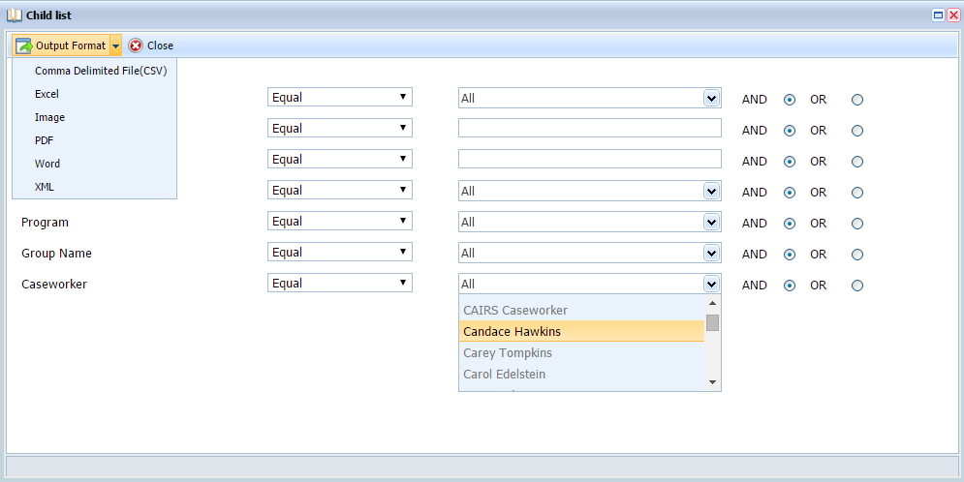

Tables and Procedures

|  |  |  |  |  |
| --- | --- | --- | --- | --- |
| **#** | **Name** | **Table/SP** | **Database** | **Module** |
| **1** | rptReportMaster | Table | Irriscentral | PortalAdmin |
| **2** | rptAgencyAssignment | Table | Irriscentral | PortalAdmin |
| **3** | rptCategory | Table | Irriscentral | PortalAdmin |
| **4** | rptReports | Table | Agency DB | Agency |
| **5** | rptCategory | Table | Agency DB | Agency |
| **6** | rptCategoryUsers | Table | Agency DB | Agency |
| **7** | rptReportUsers | Table | Agency DB | Agency |
| **8** | rptFilters | Table | Agency DB | Agency |
| **9** | rptFiltersAssigned | Table | Agency DB | Agency |
| **10** | lkp_FilterOperator | Table | Agency DB | Agency |
| **11** | USP_rptReportMasterList | SP | Irriscentral | PortalAdmin |
| **12** | USP_rptAgencyList | SP | Irriscentral | PortalAdmin |
| **13** | USP_rptCategoryList | SP | Irriscentral | PortalAdmin |
| **14** | USP_rptReportMasterUpdate | SP | Irriscentral | PortalAdmin |
| **15** | USP_rptReportMasterDelete | SP | Irriscentral | PortalAdmin |
| **16** | USP_rptAgencyAssignmentUpdate | SP | Irriscentral | PortalAdmin |
| **17** | usp_RptCategoryList | SP | Agency DB | Agency |
| **18** | USP_rptReportsAssignments | SP | Agency DB | Agency |
| **19** | USP_rptFiltersAssigned | SP | Agency DB | Agency |
| **20** | usp_RptUserGroupUpdate | SP | Agency DB | Agency |
| **21** | USP_rptCategoryDelete | SP | Agency DB | Agency |
| **22** | USP_rptCategoryReportList | SP | Agency DB | Agency |
| **23** | USP_rptCategoryInsert | SP | Agency DB | Agency |
| **24** | USP_rptCategoryUpdate | SP | Agency DB | Agency |
| **25** | USP_rptReportsUpdate | SP | Agency DB | Agency |
| **26** | USP_rptReportsList | SP | Agency DB | Agency |
| **27** | USP_rptFiltersList | SP | Agency DB | Agency |
| **28** | USP_rptFilterOperatorList | SP | Agency DB | Agency |
| **29** | usp_RptUserGroupList | SP | Agency DB | Agency |
| **30** | USP_rptCategoryReportListforUser | SP | Agency DB | User |
| **31** | USP_DltrptCategoryUsers | sp | Agency DB | Agency |
| **32** | USP_rptCategoryReportDelete | SP | Agency DB | Agency |